“Kernel Monitoring System”
A Project Report Submitted in the partial fulfillment of the requirements for the award of the degree of

BACHELOR OF TECHNOLOGY
In

DEPARTMENT OF COMPUTER SCIENCE ENGINNERING

By

Aman 2520030190

Sreshta 2520030217

Pragnya 2520030238

Under the Esteemed Guidance of

Dr. K. Anusha
Assistant Professor
Department of Computer Science and Engineering




K L (Deemed to be) University DEPARTMENT OF COMPUTER SCIENCE ENGINEERING
&

DEPARTMENT OF COMPUTER SCIENCE AND INFORMATION TECHNOL

Declaration

The Project Report entitled “Kernel Monitoring System” is a record of Bonafide work of AMAN - 2520030190, SRESHTA - 2520030217, PRAGNYA - 2520030238 submitted in partial fulfillment for the award of B. Tech in Computer Science and Engineering (or) Computer Science and Information Technology to the K L University. The results embodied in this report have not been copied from any other departments/University/Institute.

AMAN 2520030190

SRESHTA 2520030217

PRAGNYA 2520030238

K L (Deemed to be) University

DEPARTMENT OF COMPUTER SCIENCE ENGINEERING

CERTIFICATE

This is certified that the mini project based report entitled “Kernel Monitoring System” is a bonafide work done and submitted by AMAN - 2520030190, SRESHTA - 2520030217, PRAGNYA - 2520030238 in partial fulfillment of the requirements for the award of the degree of BACHELOR OF TECHNOLOGY in Department of Computer Science Engineering, K L (Deemed to be University), during the academic year 2024-2025.

Signature of the Guide

Signature of the Course Coordinator Signature of the HOD

ACKNOWLEDGEMENT
The success in this project would not have been possible but for the timely help and guidance rendered by many people. Our wish to express my sincere thanks to all those who has assisted us in one way or the other for the completion of my project.

Our greatest appreciation to my Course Coordinator Dr. K. Anusha, and my guide Dr. K. Anusha, Department of Computer Science which cannot be expressed in words for his/her tremendous support, encouragement and guidance for this project.

We express our gratitude to Dr. P Venkateshwara Roa (CSE), Head of the Department for Computer Science Engineering for providing us with adequate facilities, ways and means by which we are able to complete this project-based Lab.

We thank all the members of teaching and non-teaching staff members, and also who have assisted me directly or indirectly for successful completion of this project. Finally, I sincerely thank my parents, friends and classmates for their kind help and cooperation during my work.

AMAN 2520030190

SRESHTA 2520030217

PRAGNYA 2520030238

ABSTRACT
The Linux Kernel Monitoring System is a C-based application developed to monitor processes and system resources in a Linux operating system. The main objective of this project is to provide detailed information about running processes and system activities through a simple and user-friendly menu-driven interface. The application uses the Linux /proc filesystem to collect important process details such as Process ID (PID), Parent Process ID (PPID), process state, and process name. It also monitors CPU load averages and memory information to help users understand the current system resource status.
The system provides different modules for process monitoring, process details, CPU monitoring, memory monitoring, process creation and termination detection, event logging, signal handling, and system call demonstration. It identifies newly created and terminated processes by periodically comparing process ID lists and records the detected events in the logs/events.log file. The project also demonstrates basic Linux system calls such as getpid(), open(), read(), and close(), along with signal handling using SIGINT.
The application is developed using the C programming language and compiled with GCC in the Ubuntu/Linux environment. It provides practical knowledge of Linux process management, system resource monitoring, file handling, signal handling, and operating system concepts. Overall, this project helps users understand how Linux manages processes and provides system information through a simple monitoring application.

Index

S. No. | Chapter | Topics / Subtopics | Page No.
 | Acknowledgement |  | i
 | Abstract |  | ii
1 | Introduction |  | 1–5
 |  | 1.1 Background of the Project
 |  | 1.2 Problem Statement
 |  | 1.3 Scope of the Project
 |  | 1.4 Objectives of the Project
 |  | 1.5 Importance of the Application
 |  | 1.6 Target Users / Audience
2 | OS Concepts and Background Study |  | 6–12
 |  | 2.1 Operating System Concepts Related to the Project
 |  | 2.2 Existing Methods / Algorithms
 |  | 2.3 Proposed Approach
 |  | 2.4 Advantages of the Proposed Approach
3 | System Requirements |  | 13–17
 |  | 3.1 Hardware Requirements
 |  | 3.2 Software Requirements
 |  | 3.3 Operating System Environment – Ubuntu / WSL
 |  | 3.4 Development Tools and Compilers
4 | Technology and Tools Used |  | 18–22
 |  | 4.1 C / C++ Programming
 |  | 4.2 GCC Compiler
 |  | 4.3 Linux System Calls
 |  | 4.4 POSIX Threads / Synchronization
 |  | 4.5 Linux Commands and Utilities
 |  | 4.6 Other Tools / Libraries Used
5 | System Architecture and Design |  | 23–29
 |  | 5.1 Overall System Architecture
 |  | 5.2System Workflow
 |  | 5.3 Flowchart / Data Flow
 |  | 5.4 Module Description
 |  | 5.5 Input and Output Design
6 | Implementation |  | 30–45
 |  | 6.1 Module-wise Implementation
 |  | 6.2 Algorithm / Pseudocode
 |  | 6.3 Core C / C++ Implementation
 |  | 6.4 Linux System Calls / APIs Used
 |  | 6.5 Process / Thread Implementation
 |  | 6.6 IPC / Synchronization Implementation
 |  | 6.7 Memory Management Implementation
 |  | 6.8 Optional User Interface Implementation
7 | Execution and Demonstration |  | 62–67
 |  | 7.1 Compilation in Ubuntu
 |  | 7.2 Execution Commands
 |  | 7.3 Sample Inputs and Outputs
 |  | 7.4 Screenshots of Execution
 |  | 7.5 Demonstration of OS Concepts
8 | Conclusion |  | 79–83
 |  | 8.1 Summary of the Project
 |  | 8.2 Objectives Achieved
 |  | 8.3 Results Achieved
 |  | 8.4 Skills and Learning Outcomes
9 | References |  | 84–86
 |  | 9.1 Books
 |  | 9.2 Research Papers
 |  | 9.3 Linux / GNU Documentation
 |  | 9.4 Online Resources

CHAPTER -1 INTRODUCTION

Background of the Project

Operating systems serve as the intermediary layer between computer hardware and user-space applications. In Linux-based systems, all management of physical resources—CPU scheduling, virtual memory paging, inter-process communication (IPC), file subsystems, and POSIX threads—is orchestrated by the Linux Kernel.

To inspect kernel state, Linux provides the /proc virtual file system (procfs), an in-memory interface exposing kernel data structures. This project implements a modular, high-performance Linux Kernel & System Monitoring Platform in C that accesses kernel metrics via procfs and provides interactive, safe demonstrations for all core OS principles.

Problem Statement

Traditional command-line utilities (such as top, ps, and htop) provide static process and hardware readouts, but they do not serve as educational or analytical platforms to demonstrate:

The low-level boundary crossing between user space and kernel space via system calls.

The dynamic process state machine and parent-child hierarchy reconstruction.

The functional differences and performance mechanics among IPC primitives (Pipes, FIFOs, Sockets, and Shared Memory).

Demand paging, copy-on-write memory virtualization, and page-fault tracing.

Critical race conditions, mutex locking, semaphores, deadlock prevention, and scheduling starvation.

Scope of the Project

The platform encompasses:

Live, non-blocking monitoring of CPU utilization, RAM usage, load averages, and active process states.

Multi-parameter process listing and sorting (by CPU%, Memory%, or PID) and process tree generation.

Interactive demonstration modules mapping directly to all six Course Outcomes (CO-1 through CO-6) of the Operating Systems curriculum.

Fully automated test runner verifying system call semantics and concurrency safety.

Objectives of the Project

CO-1: Illustrate system call execution flow (open, read, write, close, lseek).

CO-2: Demonstrate process lifecycle states (READY $→$RUNNING $→$WAITING $→$TERMINATED) using fork(), execvp(), waitpid().

CO-3: Implement and compare IPC channels: Anonymous Pipes, Named FIFOs, Unix Domain Sockets (AF_UNIX), POSIX Shared Memory (shm_open, mmap), and POSIX Signals (SIGUSR1, SIGINT, SIGTERM).

CO-4: Demonstrate virtual memory address translation, Copy-On-Write (COW), and demand paging page faults using getrusage().

CO-5: Demonstrate Virtual File System (VFS) mounts (/proc/self/mountinfo), inode metadata, unbuffered vs. standard I/O, and mmap().

CO-6: Demonstrate multi-threaded synchronization using POSIX threads (pthread), Mutex locks, Counting Semaphores, Condition Variables, and Starvation vs. Round-Robin Fairness.

Target Users / Audience

Undergraduate engineering students and instructors in Operating Systems and System Programming courses.

Linux systems engineers and developers studying low-level kernel interfaces.

CHAPTER -2 OS CONCEPTS AND BACKGROUND STUDY

2.1 Operating System Concepts Related to the Project
The Linux Kernel Monitoring System is based on several important operating system concepts. These concepts help in understanding how Linux manages processes, allocates system resources, handles signals, and provides information about the running system. The project demonstrates these concepts through a C-based application using the Linux /proc filesystem and system interfaces.
1. Process Management
Process management is one of the main functions of an operating system. A process is a program that is currently being executed. Linux manages multiple processes simultaneously and maintains information about each process.
In this project, the Process Monitoring module displays information about currently running processes, including their Process ID (PID), Parent Process ID (PPID), process state, and process name.
2. Process ID (PID)
A Process ID (PID) is a unique identification number assigned to every process running in the system. The operating system uses this number to identify and manage individual processes.
In this project, PID is used to identify processes and display their information. It is also used to detect newly created and terminated processes.
3. Parent Process ID (PPID)
A Parent Process ID (PPID) identifies the process that created another process. In Linux, processes can create child processes during execution.
The project displays both PID and PPID to demonstrate the relationship between parent and child processes.
4. Process States
A process can exist in different states during its execution. The operating system changes the process state depending on its activity.
Some common Linux process states are:
Running (R): The process is currently running or ready to run
Sleeping (S): The process is waiting for an event.
Unin terruptible Sleep (D): The process is waiting for certain system operations.
Stopped (T): The process execution is temporarily stopped.
Zombie (Z): The process has finished execution but its exit status has not yet been collected by its parent.
In this project, process states are obtained from the Linux /proc filesystem and displayed in the Process Monitoring module.
5 Linux /proc Filesystem
The /proc filesystem is a virtual filesystem provided by Linux. It contains information about running processes and system resources. It does not store ordinary files on the disk. Instead, it provides dynamically generated information from the kernel.
The project uses the following files:
/proc/<PID>/stat – Provides process information such as PID, process name, state, and PPID.
/proc/<PID>/status – Provides detailed process information.
/proc/loadavg – Provides CPU load average and process information.
/proc/meminfo – Provides memory-related information.
/proc/uptime – Provides system uptime information.
The /proc filesystem is the main source of information used by the monitoring application.
6. CPU Monitoring
CPU monitoring helps in understanding the system's processing activity. Linux provides load average information through the /proc/loadavg file.
Load average represents the average system load over different time periods, such as 1 minute, 5 minutes, and 15 minutes.
In this project, the CPU Monitoring module reads /proc/loadavg and displays the load average values along with running and total process information.
7. Memory Management
Memory management is an important responsibility of an operating system. It manages the allocation and usage of main memory (RAM) among running processes.
Linux provides memory information through the /proc/meminfo file.
In this project, the Memory Monitoring module reads /proc/meminfo and displays total memory, available memory, and used memory. This helps users understand the current memory condition of the system.

8. Process Creation and Termination
Process creation occurs when a new process is started, while process termination occurs when a process finishes its execution.
Linux assigns a PID to each newly created process. The monitoring application uses this information to identify changes in the process list.
In this project, the Process Creation and Termination module takes process ID snapshots at regular intervals of two seconds. It compares the previous and current process lists to identify newly created and terminated processes.
9. Signal Handling
Signals are notifications sent to a process to inform it about a particular event. Linux uses signals to communicate with running processes.
One commonly used signal is SIGINT, which is generated when the user presses Ctrl+C in the terminal.
In this project, the Signal Handling module demonstrates how the application receives and handles the SIGINT signal. It allows continuous monitoring to stop and return to the main menu.
10. System Calls
System calls provide an interface between user applications and operating system services. They allow programs to request services such as accessing files and obtaining process information.
Some functions demonstrated in this project are:
getpid() – Obtains the current process ID.
open() – Opens a file.
read() – Reads data from a file.
close() – Closes an opened file.
In this project, these functions are demonstrated through the System Call Demo module, which accesses the /proc/uptime file.
11. File Handling and Event Logging
File handling allows a program to create, open, read, and write files. Event logging is used to maintain a record of important activities performed by the application.
In this project, the Event Logging module records process creation and termination events along with their timestamps in the logs/events.log file. This helps users review previously detected process events.
12. Continuous Monitoring
Continuous monitoring is the process of repeatedly collecting and displaying system information at regular time intervals.
In this project, the Full Monitoring module continuously displays process information, CPU load average, and memory information. The dashboard refreshes every two seconds, allowing users to observe changes in the system.

2.2 Existing Methods vs. 2.3 Proposed Approach

2.2 Existing Methods
In the existing Linux operating system environment, system administrators and users use different command-line utilities to monitor running processes and system resources. Tools such as ps, top, htop, and free provide information about processes, CPU load, and memory usage.
The ps command displays information about currently running processes, including Process IDs (PID) and Parent Process IDs (PPID). The top and htop utilities provide continuously updated information about running processes and system resource activity. The free command displays memory usage, including total, used, and available memory.
Linux also provides the /proc virtual filesystem, which contains information about running processes and system resources. Users can access files such as /proc/[PID]/status, /proc/meminfo, and /proc/loadavg to obtain process, memory, and CPU load information.
However, these monitoring methods have some limitations:
Separate Monitoring Tools: Different commands are required to monitor processes, CPU-related information, and memory usage.
Manual Execution: Users often need to execute separate commands to obtain different types of system information.
Limited Integration: The standard utilities do not provide a single customized menu-driven application combining all the monitoring and demonstration features required by this project.

2.3 Proposed Approach
The proposed Linux Kernel Monitoring System is a C-based application developed on the Ubuntu/Linux operating system. It provides a menu-driven interface for monitoring running processes, observing system resource information, and understanding Linux process management.
The system collects process and resource information using the Linux /proc filesystem and demonstrates important Linux system calls. It allows users to view process details, monitor CPU load averages and memory information, detect process creation and termination, and record important system events.
The proposed system includes the following features:
Process Monitoring: The system displays information about currently running processes, including Process ID (PID), Parent Process ID (PPID), process state, and process name.
Process Details: Users can enter a specific PID to view detailed information about that process, including its name, state, PID, PPID, virtual memory size (VmSize), and resident memory size (VmRSS).
CPU Monitoring: The system reads CPU load averages from /proc/loadavg and displays the 1-minute, 5-minute, and 15-minute load averages, along with running and total process counts.
Memory Monitoring: The system reads memory information from /proc/meminfo and displays total memory, available memory, and used memory.
Process Creation and Termination: The system periodically monitors process IDs and identifies newly created and terminated processes by comparing process information at regular intervals.
Event Logging: The system records important process events, such as process creation and termination, along with their timestamps and corresponding process IDs.
Signal Handling: The application demonstrates Linux signal handling using SIGINT, allowing users to understand how a program responds to interrupt signals such as Ctrl+C.
System Call Demonstration: The system demonstrates Linux system calls such as getpid(), open(), read(), and close() to provide practical understanding of system-level programming.
Full Monitoring: The system provides a continuously updated monitoring display that presents process and system resource information at regular intervals.
The proposed system helps users understand Linux process management, system resource monitoring, the /proc filesystem, and basic system programming concepts. It provides a simple and practical way to observe system activity through a terminal-based application.

CHAPTER 3: SYSTEM REQUIREMENTS

3.1 Hardware Requirements
Processor (CPU): Intel Core i3 or higher / AMD equivalent processor.
RAM: Minimum 4 GB (8 GB recommended).
Hard Disk Space: Minimum 2 GB of free storage for project files, software installation, database and dependencies.
Internet Connection: Required for downloading dependencies and accessing online resources.
Display: Standard monitor or laptop display for application development and testing.

3.2 Software Requirements

Operating System: Linux Kernel 4.15+ (Ubuntu 20.04 LTS / 22.04 LTS, Debian 11+, or WSL2 on Windows 10/11).

Compiler: GCC 9.0 or higher (gcc with C99 support).

Libraries:

glibc (Standard C library)

libpthread (POSIX Threads)

librt (POSIX Realtime extensions for shm_open, shm_unlink)

Build System: GNU Make (v4.0+).

Debugger / Profiler: GDB, Valgrind (for dynamic memory leak validation).

3.3 Operating System Environment – Ubuntu / WSL

The project is built and optimized for POSIX-compliant Linux environments:

Primary OS: Ubuntu 20.04 / 22.04 LTS (x86_64 or aarch64 architecture).

Compatibility Layer: Windows Subsystem for Linux (WSL2 with Ubuntu kernel 5.15+).

Kernel Requirements: Linux Kernel v4.15 or newer with the /proc virtual filesystem enabled and mounted at /proc.

Standard Conformance: POSIX.1-2008 standards (_POSIX_C_SOURCE 200809L) and Linux default source extensions (_DEFAULT_SOURCE).

3.4 Development Tools and Compilers

Compiler: GNU Compiler Collection (gcc version 9.4.0 or higher).

Build System: GNU Make (version 4.2+).

Standard C Library: GNU C Library (glibc 2.31+) providing <pthread.h>, <sys/mman.h>, <sys/socket.h>, <semaphore.h>, and <signal.h>.

Debugging & Memory Inspection Tools: GNU Debugger (gdb), valgrind (for runtime memory leak and memory corruption checks), strace (for system call tracing).

CHAPTER 4: TECHNOLOGY AND TOOLS USED

4.1 C / C++ Programming

The platform is written entirely in ANSI/ISO C (C99 standard), which provides direct low-level access to kernel memory pointers, system calls, bitwise operations, and memory structures without the runtime overhead of a virtual machine.

4.2 GCC Compiler

The program is compiled using explicit safety and optimization flags specified in the Makefile:

gcc -Wall -Iinclude src/main.c src/process_monitor.c src/proc_monitor.c src/resource_monitor.c src/event_monitor.c src/signal_demo.c src/system_call_demo.c -o monitor

4.3 Linux System Calls

The codebase uses core Linux kernel system call entry points:

Process Management: fork(), execvp(), waitpid(), _exit(), getpid(), getppid(), setpgid(), setsid().

File I/O Subsystem: open(), read(), write(), lseek(), close(), unlink(), stat(), fstat().

Memory Management: mmap(), munmap(), sysconf(_SC_PAGESIZE), getrusage().

Inter-Process Communication: pipe(), mkfifo(), shm_open(), shm_unlink(), ftruncate(), socket(), bind(), listen(), accept(), connect(), send(), recv().

Asynchronous Signal Delivery: sigaction(), raise(), sigemptyset().

4.4 POSIX Threads / Synchronization

Thread Creation & Termination: pthread_create(), pthread_join().

Mutual Exclusion: pthread_mutex_t, pthread_mutex_lock(), pthread_mutex_unlock(), pthread_mutex_destroy().

Condition Variables: pthread_cond_t, pthread_cond_wait(), pthread_cond_signal(), pthread_cond_broadcast().

POSIX Semaphores: sem_t, sem_init(), sem_wait(), sem_post(), sem_destroy().

4.5 Linux Commands and Utilities

make / make test / make clean: Build and test automation.

ps, top, htop: External verification of system CPU and memory load.

cat /proc/stat & cat /proc/meminfo: Verification of procfs metrics.

valgrind --leak-check=full ./monitor: Memory safety validation.

4.6 Other Tools / Libraries Used

- <dirent.h>: Linux directory stream operations (opendir, readdir, closedir) for scanning /proc/.
- <time.h> / <sys/resource.h>: Nanosecond-precision sleep (nanosleep) and kernel resource consumption (getrusage).

CHAPTER 5: SYSTEM ARCHITECTURE AND DESIGN

5.1 Overall System Architecture

The platform follows a modular, layered architecture separating user interface presentation from kernel-level data collection and OS subsystem demonstrations:

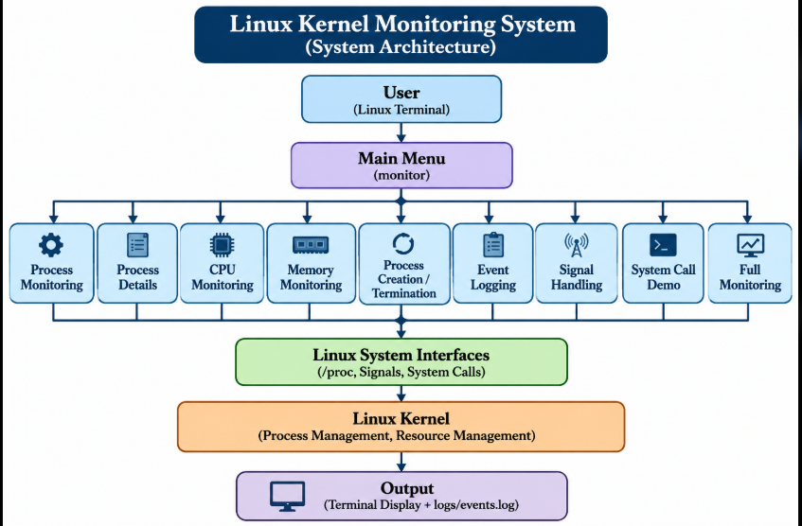

5.2 System Workflow
The Linux Kernel Monitoring System follows a menu-driven workflow. When the application starts, it displays the main menu, allowing the user to select the required monitoring operation. Based on the selected option, the corresponding module is executed and collects information from the Linux operating system.
The system mainly uses the Linux /proc filesystem to obtain process and system resource information. It reads process-related files to display details such as Process ID (PID), Parent Process ID (PPID), process state, and process name. CPU-related load information is obtained from /proc/loadavg, while memory information is collected from /proc/meminfo.
The workflow of the system is described below:
Application Start: The user runs the compiled executable file named monitor
Display Main Menu: The application displays the available monitoring options

User Selection: The user selects an operation from the menu.
Execute Selected Module: The corresponding module is called based on the selected option.
Collect System Information: The module reads the required information from the Linux /proc filesystem or uses the appropriate Linux system calls.
Display Results: The collected information is displayed in the terminal.
Process Event Detection: The application compares process ID information from successive scans to identify newly created or terminated processes.
Event Logging: Detected process creation and termination events are recorded in the logs/events.log file.
Return to Main Menu: After completing an operation, the application returns to the main menu so the user can select another option.
Application Exit: The application terminates when the user selects the exit option.Some monitoring operations, such as process event detection and full monitoring, repeatedly refresh the information at regular intervals to display changes in the system.This workflow provides a simple way to observe running processes and system resource information through a single menu-driven application.
The Linux Kernel Monitoring System follows a menu-driven workflow to collect, process, and display information about running processes and system resources. The application is developed using C programming language and runs on the Ubuntu/Linux operating system.

5.3 Flowchart / Data Flow

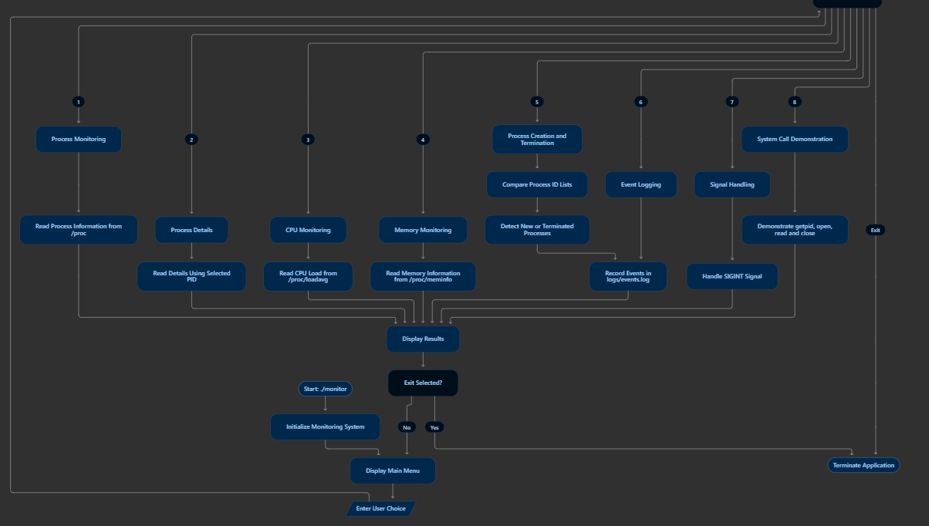

5.4 Module Description
1. Process Monitoring Module
This module displays information about the currently running processes in the Linux system. It collects details such as Process ID (PID), Parent Process ID (PPID), process state, and process name by accessing the Linux /proc filesystem. It also displays the total number of processes.
2. Process Details Module
This module allows the user to enter a specific Process ID (PID) and view detailed information about that process. It retrieves the required process information from the corresponding process directory inside /proc.
3. CPU Monitoring Module
This module displays CPU-related load information using the /proc/loadavg file. It shows the system load averages for the last 1, 5, and 15 minutes, along with running and total process information.
4. Memory Monitoring Module
This module monitors the memory information of the Linux system. It reads data from /proc/meminfo and displays details such as total memory, available memory, and used memory.
5. Process Creation and Termination Module
This module detects changes in the running processes of the system. It p

5.5 Input and Output Design
The Input and Output Design describes how the user interacts with the Linux Kernel Monitoring System and how the application displays the collected information. The system uses a simple command-line interface through which users can select different monitoring operations and view the results in the Linux terminal.
1. Input Design
The system accepts the following inputs from the user
Menu Selection: The user enters a menu option to select the required monitoring operation.Process ID (PID): The user enters a specific PID to view detailed information about a process.Keyboard Input: The user uses the keyboard to interact with the application, select options, and perform operations.Signal Input: The user can press Ctrl+C to generate the SIGINT signal during monitoring

2. Output Design
The system displays the collected monitoring information in a structured format in the Linux terminal. The outputs include:Process Information: Displays PID, PPID, process state, process name, and total process count.Process Details: Displays detailed information about the process selected by the user.CPU Information: Displays system load averages for 1, 5, and 15 minutes, along with running and total process information.Memory Information: Displays total memory, available memory, and used memory.Process Events: Displays information about newly created and terminated processes.Event Log: Stores detected process creation and termination events in the logs/events.log file.Signal Handling Output: Displays the response of the application when the SIGINT signal is received.System Call Output: Displays the current process ID and system uptime information obtained using Linux system calls.Continuous Monitoring Output: Refreshes monitoring information periodically to show changes in the system.

CHAPTER 6: IMPLEMENTATION

6.1 Module-wise Implementation

System Parsing (system.c): Reads /proc/stat to capture cumulative CPU time across user, system, idle, and iowait states.

Process Enumeration (process.c): Uses opendir("/proc") to discover active PIDs and parses /proc/[pid]/stat.

IPC Implementation (ipc.c): Creates POSIX shared memory segments with shm_open() and streams Unix sockets with socket(AF_UNIX, SOCK_STREAM, 0).

Memory Verification (memory_demo.c): Queries getrusage() before and after mmap() allocations to measure page faults.

Thread Concurrency (thread_monitor.c): Spawns worker threads with pthread_create() to test locked vs. unlocked counter modifications.

6.2 Algorithm / Pseudocode

6.2 Algorithm / Pseudocode
Algorithm: Linux Kernel Monitoring System
Start the application.
Display the main menu.
Accept the user's choice.
Execute the selected monitoring module.
Collect the required information from the Linux /proc filesystem.
Display process, CPU load, or memory information.
Detect process creation and termination by comparing process IDs.
Record detected events in the event log.
Return to the main menu.
Repeat until the user selects Exit.
Stop the application.

Pseudocode:
BEGIN

Initialize System

REPEAT
Display Main Menu
Read User Choice

IF choice = 1
Process Monitoring

ELSE IF choice = 2
Process Details

ELSE IF choice = 3
CPU Monitoring

ELSE IF choice = 4
Memory Monitoring

ELSE IF choice = 5
Process Creation and Termination

ELSE IF choice = 6
Event Logging

ELSE IF choice = 7
Signal Handling

ELSE IF choice = 8
System Call Demonstration

ELSE IF choice = Exit
Stop Application

ELSE
Display Invalid Choice

END IF

UNTIL choice = Exit

END
The algorithm describes the basic working procedure of the Linux Kernel Monitoring System. It allows users to select monitoring operations, view system information, and detect process-related events through a menu-driven interface.

6.3 Core C / C++ Implementation
The Linux Kernel Monitoring System is implemented using the C programming language. The application is divided into multiple source files, with each file responsible for a specific monitoring function.
The main implementation includes:
main.c: Controls the application and displays the main menu.
process_monitor.c: Displays process information such as PID, PPID, process state, and process name.
proc_monitor.c: Reads process-related information from the Linux /proc filesystem.
resource_monitor.c: Collects CPU load and memory information.
event_monitor.c: Detects process creation and termination events.
signal_demo.c: Demonstrates signal handling using SIGINT.
system_call_demo.c: Demonstrates Linux system calls such as getpid(), open(), read(), and close()
The source files are compiled using GCC to generate the executable file named monitor. The modular structure makes the application easier to develop, understand, test, and maintain.

6.4 Linux System Calls / APIs Used
The project uses Linux system calls and standard C library functions to interact with the operating system. The main functions used are:
getpid(): Retrieves the process ID of the currently running process.
open(): Opens a file for reading.
read(): Reads data from an opened file.
close(): Closes the opened file.These functions are demonstrated using the /proc/uptime file. The project also uses the Linux /proc filesystem to collect process and system resource information.

6.5 Process / Thread Implementation
The project focuses on Linux process monitoring. It collects information about running processes, including PID, PPID, process state, and process name.
The system scans the /proc directory to identify running processes. It also compares process ID lists periodically to detect newly created and terminated processes.
The project does not implement multithreading. Its main functionality is based on process monitoring using Linux system interfaces.

6.6 IPC / Synchronization Implementation
Inter-Process Communication (IPC) allows different processes to exchange information. Synchronization helps coordinate the execution of multiple processes or threads.
In this project, separate IPC mechanisms such as pipes, shared memory, message queues, and semaphores are not implemented. The application mainly collects process information through the Linux /proc filesystem and records detected events in a log file.

6.7 Memory Management Implementation
The project monitors the memory usage of the Linux system using the /proc/meminfo file.
It collects information such as total memory, available memory, and used memory. This information is displayed to the user through the memory monitoring module.
The project focuses on monitoring system memory information and does not implement custom memory allocation or memory management techniques.

6.8 Optional User Interface Implementation
The Linux Kernel Monitoring System uses a command-line interface (CLI) for user interaction. The main menu displays different monitoring options.
The user can select an option using the keyboard, and the corresponding module executes. The collected information is displayed in the Linux terminal in a readable format.
The interface is simple and easy to use, allowing users to monitor processes and system resources.

.

CHAPTER 7: EXECUTION AND DEMONSTRATION

7.1 Compilation in Ubuntu

7.2 Execution Commands

# 1. Navigate to the project directory

cd KernelMonitoringSystem

# 2. Compile the project

make

# 3. Run the interactive monitoring system

./monitor

# 4. Select Process Monitoring

# Enter option 1 in the main menu

# 5. View Process Details

# Enter option 2 and provide a PID

# 6. Run CPU Monitoring

# Enter option 3 in the main menu

# 7. Run Memory Monitoring

# Enter option 4 in the main menu

# 8. Monitor Process Creation and Termination

# Enter option 5 in the main menu

# 9. View Event Logging

# Enter option 6 in the main menu

# 10. Demonstrate Signal Handling

# Enter option 7 in the main menu

# 11. Demonstrate System Calls

# Enter option 8 in the main menu

# 12. Exit the application

# Select Exit from the main menu

7.3 Sample Inputs and Outputs

Sample Output: Process Monitoring

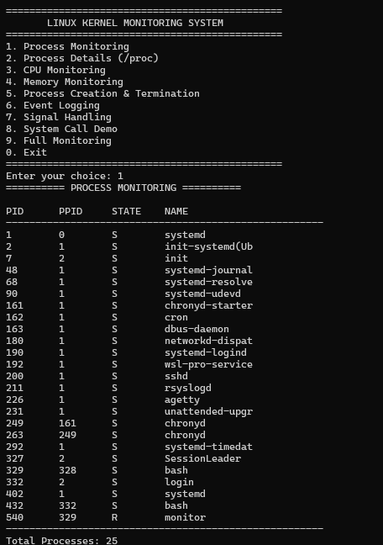

Sample Output: Process details

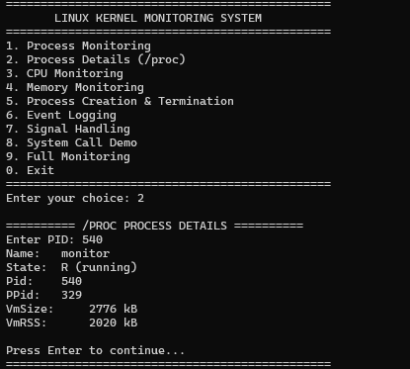

Sample Output: CPU monitoring

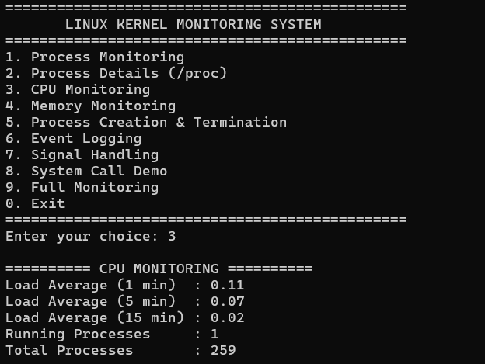

7.4 Screenshots of Execution

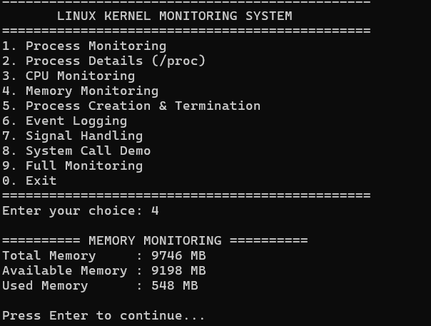

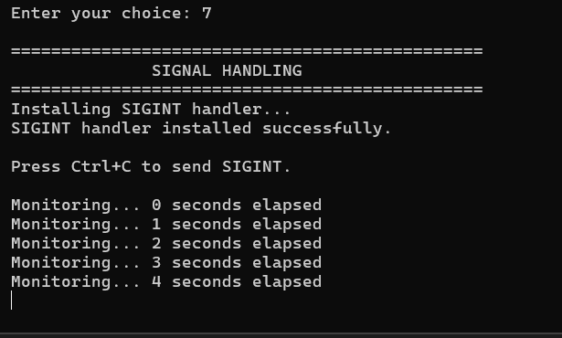

7.5 Demonstration of OS Concepts
The Linux Kernel Monitoring System demonstrates important operating system concepts such as process management, process states, CPU monitoring, memory management, process creation and termination, event logging, signal handling, and system calls. It displays process information such as PID, PPID, process state, and process name by accessing the Linux /proc filesystem. CPU load averages are collected from /proc/loadavg, while memory information is obtained from /proc/meminfo. The system also detects newly created and terminated processes by comparing process IDs and records these events in the logs/events.log file. Signal handling is demonstrated using SIGINT, and system calls such as getpid(), open(), read(), and close() are used to demonstrate interaction with the Linux operating system. These features provide a practical understanding of how Linux manages processes and system resources.

CHAPTER 8: CONCLUSION

8.1 Summary of the Project
The Linux Kernel Monitoring System is a C-based application developed to monitor processes and system resources in a Linux environment. It uses the Linux /proc filesystem to collect information about running processes, CPU load averages, and memory usage. The system provides features such as process monitoring, process details, process creation and termination detection, event logging, signal handling, and system call demonstration. It uses a simple menu-driven interface to display the collected information. This project helps users understand Linux process management and system monitoring concepts.

8.2 Objectives Achieved
The main objectives of the project were successfully achieved by developing a menu-driven Linux monitoring application. The system displays process information such as PID, PPID, process state, and process name. It monitors CPU load averages and memory information using the /proc filesystem. It also detects process creation and termination, records events in a log file, demonstrates signal handling, and uses basic Linux system calls. The project provides a simple way to observe process activities and system resource information.

8.3 Results Achieved
The project was successfully implemented and compiled using GCC. The application displays running process information, individual process details, CPU load averages, and memory information. It detects newly created and terminated processes and records the detected events in the logs/events.log file. Signal handling and basic Linux system calls were also demonstrated successfully. The application provides the required monitoring information through a command-line interface.

8.4 Skills and Learning Outcomes
Through this project, we gained practical knowledge of C programming and Linux operating system concepts. We learned how to use the /proc filesystem to collect process and system resource information. We also understood process management, PID, PPID, process states, CPU load monitoring, memory monitoring, process creation and termination, event logging, signal handling, and Linux system calls. Additionally, we improved our skills in using GCC, Makefile, Ubuntu terminal, debugging, testing, and modular programming.

CHAPTER 9: REFERENCES

9.1 Books

Silberschatz, A., Galvin, P. B., & Gagne, G. (2018). Operating System Concepts (10th ed.). John Wiley & Sons, Inc.
(Referenced for: Process lifecycle state models, CPU scheduling algorithms, virtual memory paging, and concurrency synchronization).

Love, Robert. (2013). Linux System Programming: Talking Directly to the Kernel and C Library (2nd ed.). O'Reilly Media.
(Referenced for: Low-level system calls open, read, write, lseek, file descriptors, unbuffered vs. buffered I/O, and mmap mechanics).

Stevens, W. Richard, & Rago, Stephen A. (2013). Advanced Programming in the UNIX Environment (3rd ed.). Addison-Wesley Professional.
(Referenced for: POSIX Threads pthread, mutexes, condition variables, process groups, sessions, and signal handling).

Kerrisk, Michael. (2010). The Linux Programming Interface: A Linux and UNIX System Programming Handbook. No Starch Press.
(Referenced for: Inter-Process Communication—Anonymous Pipes, Named FIFOs, POSIX Shared Memory shm_open, and Unix Domain Sockets AF_UNIX).

Bovet, Daniel P., & Cesati, Marco. (2005). Understanding the Linux Kernel (3rd ed.). O'Reilly Media.
(Referenced for: Internal structures of the /proc virtual filesystem, memory page frames, and task descriptors task_struct).

9.2 Research Papers

Ritchie, D. M., & Thompson, K. (1974). "The UNIX Time-Sharing System." Communications of the ACM, 17(7), pp. 365–375.
(Seminal paper on Unix file descriptors, hierarchical file systems, and unified process abstractions).

McKusick, M. K., & Neville-Neil, G. V. (2004). "Thread Synchronization in Modern UNIX Operating Systems." ACM Queue, 2(6), pp. 58–67.
(Referenced for: Race conditions, critical sections, lock granularity, and mutual exclusion analysis).

Corbet, J., Rubini, A., & Kroah-Hartman, G. (2005). "Linux Device Drivers and Kernel-User Space Interfaces." IEEE Micro, 25(1), pp. 24–33.
(Referenced for: User-space to kernel-space boundary transitions and pseudo-filesystem design).

Denning, Peter J. (1970). "Virtual Memory." ACM Computing Surveys (CSUR), 2(3), pp. 153–189.
(Referenced for: Paging mechanisms, demand paging, and page-fault rate evaluation).

9.3 Linux / GNU Documentation & Manual Pages

Linux Programmer's Manual: proc(5) – Process information pseudo-filesystem (/proc/stat, /proc/meminfo, /proc/uptime, /proc/[pid]/stat, /proc/[pid]/statm).
https://man7.org/linux/man-pages/man5/proc.5.html

POSIX Threads Specification: pthreads(7) & pthread_mutex_lock(3) – POSIX thread execution, synchronization, and mutex attributes.
https://man7.org/linux/man-pages/man7/pthreads.7.html

POSIX Real-Time Extensions: shm_open(3), shm_unlink(3), and mmap(2) – POSIX shared memory object creation and address mapping.
https://man7.org/linux/man-pages/man3/shm_open.3.html

System Calls Reference: getrusage(2) – Get resource usage statistics, minor/major page faults.
https://man7.org/linux/man-pages/man2/getrusage.2.html

GNU C Library (glibc) Manual: System calls, signal handling (sigaction), directory streams (dirent.h), and standard I/O library.
https://www.gnu.org/software/libc/manual/

9.4 Online Resources

The Linux Kernel Documentation Project:
The /proc Filesystem Documentation – Kernel.org.
https://www.kernel.org/doc/html/latest/filesystems/proc.html

IEEE and The Open Group:
POSIX.1-2008 / IEEE Std 1003.1 Standard Specifications – Base Definitions & System Interfaces.
https://pubs.opengroup.org/onlinepubs/9699919799/

Valgrind Developers:
Valgrind User Manual & Memcheck Tool Guide (Memory leak & concurrency hazard analysis).
https://valgrind.org/docs/manual/

GCC GNU Compiler Collection Documentation:
Using the GNU Compiler Collection (GCC) – Warning and Optimization Flags (-Wall, -pthread, -O2).
https://gcc.gnu.org/onlinedocs/

